During the tunnel construction phases, the time increment used for the time-dependent analysis is automatically managed by the ANSYS solver. The latter makes use of a semi-implicit scheme for the viscoplasticity solution, together with an automatic time stepping algorithm [34] in which the time step is defined as a fraction of time *tp* for the phases of longitudinal tunnel excavation and as a fraction of *tpg* for the phases of transverse gallery excavation. Furthermore, distinct time steps are considered for the time-dependent analysis during tunnelling process and post-excavation stage. After complete tunnel construction phases, the analysis is carried out for a period of about 3000 days to assess the time evolving deformation as well as long-term viscous effects on the final equilibrium of the tunnel structure. At that respect and in anticipation of the numerical results of the subsequent sections, the characteristic viscoplastic relaxation time [35] is equal to *r¯* = *ηƒ*0/*E* , which is close to 30 days for model data of Table 2.

The one-dimensional representation of the constitutive behavior is shown in Fig. 1.

Figure 1: Rheological representation of the elastoplastic-viscoplastic model.

In the three-dimensional context, the plasticity component of constitutive behavior is described by a Drucker-Prager plastic flow surface given by

Equation (2)

. . . respectively. Drucker-Prager plasticity surface inscribed to the Mohr-Coulomb surface shall be considered throughout the subsequent analysis [5]:

Equation (3)

# Preliminary numerical simulations and computational model verification

This section is aimed at applying the computational modeling to simulate deformation and stress in two academic twin tunnels configurations. The numerical results provided in these illustrative applications may be viewed as preliminary verifications of the F.E formulation. The first application refers to unlined twin tunnels excavated in an elastic rock mass, whereas the second application addresses the situation of unlined twin tunnels excavated in an elastoplastic medium.

## Unlined twin tunnels in elastic medium

In the context of plane strain conditions, Guo et al. [6] addressed the configuration of deep twin tunnels excavated in a homogeneous elastic medium in which prevails a hydrostatic initial stress distribution. The authors formulated approximate analytical solutions for the stress distribution establishing far behind the face, which are induced in the rock mass by the excavation of two parallel circular tunnels. The model geometry of the twin circular tunnels as well as the loading associated with initial hydrostatic stress (i.e., *σh* = *σv*) are displayed in Fig. 12.

Simulation of the problem has been addressed by means of the 3D finite element model and the numerical results

obtained for the stress distribution far behind the faces of the twin tunnel shall be compared to the analytical stress solution derived by Guo et al. [6] in the framework of plane strain conditions. The simulations have been performed taking advantage of symmetry with respect to the midplane between twin tunnels and considering the following model data: tunnel radius *Rt* = 4 m, rock Young modulus *E* = 500 MPa and Poisson ratio *v* = 0*.*23, isotropic initial stresses of *σu* = *σh* = 2*.*2 MPa.

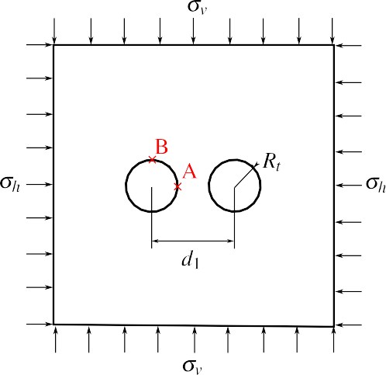

**Figure 12:** Geometry model and loading mode of the twin circular tunnels studied in Guo et al. [6].

Denoting by *uy* the displacement component following the *y*-axis, Fig. 13 displays the convergence curves *UB* = −*uy*(*B*)/*Rt* that characterize the inward movement at the tunnel roof *B*(*x* = 0*, y* = *Rt, s*) as a function of normalized longitudinal distance to the facing. Several values of normalized distances between the twin tunnels axes *d*1/2*Rt* have been investigated, and the configuration of single tunnel may be viewed as the limiting case *d*1/2*Rt »* 1.

It is recalled that in the latter configuration, the convergence far from the tunnel face that is obtained from an elastic analysis reads *U* = *σu*(1 + *v*)/*E*. As expected, this figure indicates that the closer the longitudinal tunnels, the greater the convergence at the roof.



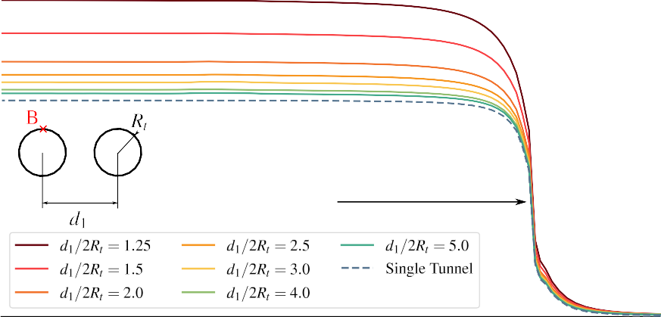

Excavation face

**Figure 13:** Convergence profiles at the tunnel roof (point B).

The tunnel deformation anisotropy induced by the twin tunnels proximity is illustrated in Fig. 14, which plots the ratio *UB* /*UA* = *uy*(*B*)/*ux*(*A*) between the vertical displacement *uy* at the roof B and the horizontal displacement *ux* at the side wall *A*(*x* = *Rt, y* = 0*, z*). The results shown in this figure refer to a tunnel section located far behind the facing at normalized distance *z*/*Rt* = –25. They emphasize the significative tunnel ovalization induced by the proximity of twin tunnel as the distance *d*1/2*Rt* decreases.



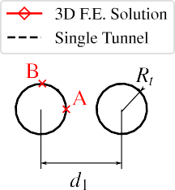

**Figure 14:** Illustration of the tunnel wall deformation anisotropy induced by twin tunnels proximity.

The stress distribution prevailing far from the facing that were obtained from the 3D numerical simulations are compared in Fig. 15 to the stress solutions derived analytically and numerically in Guo et al. [6]. In this figure, the tangential stress concentration factor *σyy*/*σv* computed at the side wall *A* is plotted for several values of the normalized twin tunnels distance. The results of the theoretical solution to a plate containing two circular holes of equal size presented in Ling et al. [37] are also reported in Fig. 15. It is observed that the results of the 3D finite element simulations correspond to a tunnel section located at normalized distance *z*/*Rt* = –25 from the facing, which is considered sufficient for the plane strain conditions to establish. Interestingly, the tangential stress concentration obtained for a deep single tunnel under plane strain condition simply reads *σyy*/*σv* = 2. Although the overall agreement observed between the different predictions, it appears from the comparison that the approximate analytical stress solution provided in [6] slightly overestimates the tangential stress computed at point A as the value of distance *d*1/2*Rt* increases.



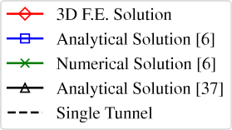

**Figure 15:** Tangential stress concentration factor at the side wall A versus twin tunnels distance *d*1/2*Rt*.

Finally, Fig. 16 displays the distribution of tangential (orthoradial) stress *σϴϴ* around the tunnel boundary

*r* = *Rt,* 0 ≤ *ϴ* ≤ *л* considering *d*1/2*Rt* = 1*.*5. The predictions of stress component *σϴϴ* obtained from the 3D finite

element simulations far behind the facing are shown together with the strain plane solutions derived analytically in

[6], emphasizing the ability of the computational model to accurately capture the effect of tunnels proximity on stress distribution.

-3.80

-3.74

-4.13

Analytical Solution [6]

-6.72

-4.97

-3.80

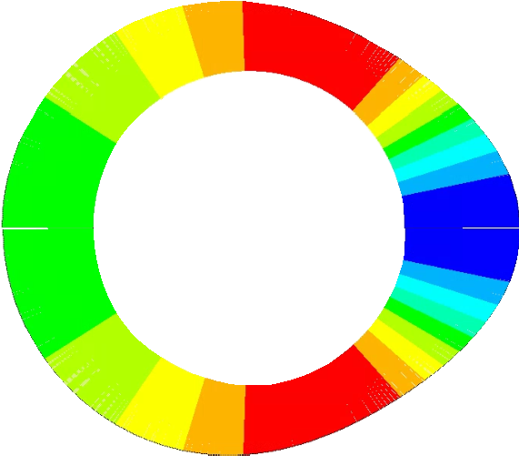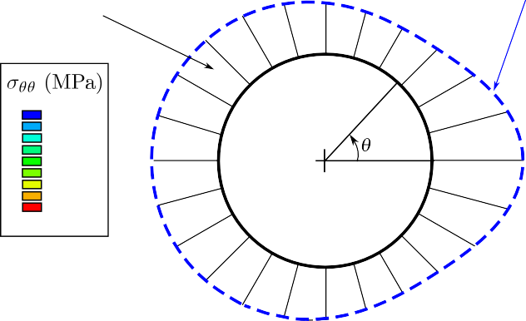

3D F.E. Solution

-6.30

-5.99

-5.69

-5.38

-5.07

-4.76

-4.45

-4.15

-3.84

-3.53

-5.00

**Figure 16:** Distribution of tangential stress *σϴϴ* around the tunnel wall prevailing far behind the facing (twin tunnels distance

*d*1/2*Rt* = 1*.*5).

Keeping in mind it addresses only an academic configuration, the results provided in this section may be viewed as a first preliminary verification of the accuracy of the computational model formulated for the mechanical interaction in deep twin tunnels.

## Unlined twin tunnels in elastoplastic medium

In the analysis developed by Ma et al. [9], an approximate analytical solution has been formulated for the stresses and the plastic zone boundary around deep twin circular tunnels excavated in a homogeneous elastoplastic medium. The approach carried out under the assumption of plane strain condition makes use of the conformal transformation in the complex variable method to transform the solution of the elastic-plastic interfaces into the determination of the mapping function coefficients.

The geometry model and boundary loading conditions associated with the initial stress state are the same as depicted Fig. 12. Unlike the configuration studied in the preceding section, anisotropic initial stress distributions defined by  shall be considered in the present analysis. As regards the rock constitutive model, an elastic-perfectly plastic behavior defined by a Mohr-Coulomb criterion with associated plastic flow rule has been adopted in the study. Furthermore, the formulation of stress solution for twin tunnels configuration was based on the premise that the plastic zone around each tunnel completely encloses the tunnel edge and the two plastic zones are not connected.

For the comparison purposes, numerical simulations are carried out by means of the 3D finite element model with the aim to investigate the effect of twin tunnels proximity on the tunnel wall deformation. The following model data has been considered in the F.E simulations: tunnel radius *Rt* = 1 m, rock Young modulus *E* = 20 GPa, Poisson ratio *v* = 0*.*3, friction angle *ø* = 30◦, cohesion *c* = 5 MPa or 2.5 MPa, initial vertical stress *σv* =30 MPa or 40 MPa, initial horizontal stress *σh* = 30 MPa or 40 MPa. The simulation took advantage Symmetry with respect to the midplane between the twin tunnels has been used for in the F.E discretization model.

Similarly to the analysis developed in the preceding section, the convergence curves *UB* = –*uy*(*B*)/*Rt*, which reflects the inward movement at the tunnel roof *B*(*x* = o*, y* = *Rt, z*), is depicted in Fig. 17 as a function of normalized longitudinal distance to the tunnel face. Several values of normalized distances between the twin tunnels axes *d*1/2*Rt* have been investigated, together with the reference configuration of single tunnel, the latter being viewed as the limiting case *d*1/2*Rt »* 1. As it could be expected from such simulations, this figure indicates that the proximity of tunnels significantly increases the convergence at the tunnel roof for small values, say *d*1/2*Rt <* 2, of twin tunnel spacing. However, this effect rapidly become negligible as soon as the tunnel spacing increases.

**Figure 17:** Convergence profiles at the tunnel roof (point B): *c* = 5 MPa, *σv* = *σh* = 30 MPa.

.

An important feature of the twin tunnels deformation is related to the anisotropy induced by the mutual interaction as the normalized tunnel spacing *d*1/2*Rt*  decreases*.* In that respect, anisotropy of tunnel deformation is illustrated in Fig. 18, which presents the variations of the ratio *UB* /*UA* = *uy*(*B*)/*ux*(*A*) between the vertical displacement *uy* at the roof B and the horizontal displacement *ux* at the side wall *A*(*x* = *Rt, y* = 0*, z*) as a function of normalized twin tunnel spacing *d*1/2*Rt* . These results refer to a tunnel section located far behind the facing at normalized distance *z*/*Rt* = –35. As observed in the elastic case studied in the preceding section, the proximity of twin tunnels reflected by small values of normalized distance *d*1/2*Rt*  is responsible for tunnel ovalization. The magnitude of horizontal displacement at the side wall A is actually larger in than that of vertical displacement at the tunnel roof B, thus indicating an ovalization in the vertical direction (i.e., parallel to *y*-axis).

**Figure 18:** Tunnel wall deformation anisotropy induced by twin tunnels proximity: *c* = 5 MPa, *σv* = *σh* = 30 MPa.

The stress distribution prevailing far from the facing that were obtained from the 3D numerical simulations are compared in the to the approximate stress solutions derived by Ma et al. [9] within the context of plane strain conditions. Fig. 19 displays such a comparison in terms of predicted plastic zone surrounding the twin tunnels considering a normalized tunnel spacing of *d*1/2*Rt* = 2*.*5. Different values have been considered for rock cohesion *c* and initial stresses *σv* and *σh*. It appears from the latter figure that the finite element modeling produces predictions very similar to those provided in [9]. The results also illustrate that larger plastic zones arise when the cohesion *c* is smaller.

**Figure 19:** The plastic zone extent obtained from the present F.E simulations and from the stress solution provided in [9].

Further comparisons are shown in Fig. 20, which presents the plots of radial *σrr,* and orthoradial *σϴϴ* stress components along three radial paths defined in polar coordinates by *ϴ* = 45◦*,* 90◦ and 135◦. It should be pointed out that, although the F.E element simulations make use of the Drucker-Prager yield surface inscribed to the Mohr-Coulomb one (used in the solution of Ma et al. [9]), the numerical predictions are matching well with the analytical stress solution.

**Figure 20:** Distribution of radial and orthoradial stress components along different radial directions: comparison between numerical and analytical predictions.

.

# Numerical Results and Discussion

To develop the parametric analyses, we employed the constitutive parameters of the clay rock mass in the Paris basin (specifically in Aisne), as detailed in Piepi [22] and Rousset [18]. These parameters, shown in Table 2, were derived qualitatively from various axisymmetric triaxial compression tests, including cyclic and creep tests conducted under undrained conditions. Previous research by Giraud [20] indicates that for Aisne clay rocks, characterized by low porosity (typically less than 20%), hydromechanical coupling has minimal significance. The delayed effects primarily stem from material viscosity, with a low proportion attributable to pore pressure redistribution (hydraulic diffusion). The material exhibits high density (ranging from 2.01 to 2.57) and a low average water content (between 3 to 11%). Another characteristic is that irreversible deformations are observed in cyclic tests even at very small values of axial deformation (less than 0.3%). Furthermore, for confinement values exceeding 10 MPa (approximately the in situ confinement), the maximum deviation remains practically constant, suggesting a Tresca-type failure criterion.

During creep tests on this material, it was observed that creep deformations are of comparable magnitude to deformations observed during instantaneous tests, and there exists a deviatoric stress threshold beyond which creep phenomena initiate. Moreover, it was found that the influence of confining pressure on creep phenomena can be disregarded. Comparing both behaviors—instantaneous and delayed—reveals that short-term cohesion exceeds long- term cohesion, with the ratio between these two cohesion values ranging between 1.2 and 2.

For the lining, we employed typical values for ordinary reinforced concrete.

These parameters are shown in Table 2. In these analyses the radius is *Rt* = 1 m and excavation speed is 12.5 m/day.